**Group Project**

**Title of project:**

**Research on efficient hydrothermal treatment of sewage sludge**

Name: ZHANG YUEKANG

Student ID: 58136250

Tutor: Prof. Yiming QIN

**Abstract**

The hydrothermal reaction process is a process of water removal and decarboxylation. Compared with its raw material urban sludge, the O/C and H/C atomic ratios of the hydrothermal reaction product hydrothermal carbon are reduced, like coalification, and the volatile matter, nitrogen and sulfur contents are also reduced. At the same time, the hydrothermal carbonization process is also closely related to temperature, time, and liquid-to-solid ratio. The best conditions obtained were: 223°C, reaction time 31 minutes, liquid-to-solid ratio 27%, and the corresponding best results were: calorific value 9.63 MJ/kg, yield 58.9%.

This process realizes the transformation and enrichment of organic matter in sludge through hydrothermal reaction under high temperature and high-pressure conditions and produces hydrothermal carbon materials like coal. During the reaction process, the oxygen and hydrogen elements in the raw sludge are gradually removed, thereby reducing the O/C and H/C ratios in the hydrothermal carbon. At the same time, impurities such as volatile matter, nitrogen and sulfur are also removed to a certain extent, improving the quality of hydrothermal carbon. The optimal process parameters of this process are obtained through optimization research on factors such as temperature, time, and liquid-to-solid ratio. Under these conditions, the calorific value and yield of the product can reach optimal levels. This technology provides an effective way for sludge reduction and resource utilization.

**Introduction**

With the advancement of urbanization in China and Hong Kong, the effective treatment of municipal sludge has gradually received attention. As the residue of sewage treatment, untreated or improperly treated sludge can easily pose a threat to the environment and human health. However, as the demand for renewable energy increases, sludge is rich in organic matter and nutrients such as protein and fat (nitrogen 37%, phosphorus 45%), and municipal sludge has great potential in energy and resource utilization (**Figure 1**). Based on the above reasons, it is necessary to rationally utilize municipal sludge, and there is an urgent need to develop corresponding efficient resource processing technology.

However, municipal sludge with high moisture and nitrogen content needs to be dehydrated before co-combustion with coal, and the pyrolysis and gasification process of sludge will be accompanied by the production of large amounts of nitrogen-containing gases such as NH3 and HCN. Under combustion oxidation conditions, NH3 and HCN are important precursors for the formation of nitrogen oxides. Therefore, when municipal sludge with high moisture and nitrogen content is co-combusted with coal, deep dehydration requires high energy consumption and may produce excessive NOx emissions, which may become an important factor limiting the application of sludge-coal combustion energy technology.

Sludge hydrothermal treatment can avoid the high energy consumption of traditional thermal drying processes. After relatively mild hydrothermal treatment, the required temperature is lower than the drying temperature [1]. The dehydration performance is significantly improved after hydrothermal carbonization, which can effectively remove the difficult-to-remove moisture inside the sludge, further achieving deep dehydration of the sludge. At the same time, hydrothermal deamination can reduce more than 65% of nitrogen in sludge. Sludge with high moisture and nitrogen content can be directly converted into clean hydrothermal carbon solid fuel like coal, which can be used for sludge gasification, etc. Therefore, the use of hydrothermal carbonization to realize sludge resource utilization is widely used.

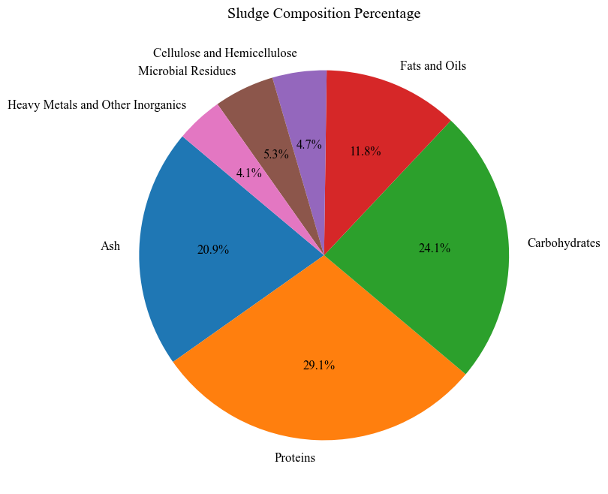

**Figure 1** Sludge Composition Percentage

**Methodology**

Mix the sludge powder and pure water evenly, put it into the 150 mL liner, and then put it into the reactor. Continue to pass N2 and maintain it for 10 minutes. This chapter studies the effects of temperature (200, 220 and 240°C), reaction time (10, 30 and 50 min) and liquid-to-solid ratio (15, 30 and 45 mL·g-1) on the hydrothermal carbon yield and calorific value. Carry out hydrothermal carbonization according to the designed temperature and reaction time, with a heating rate of 2°C/min and react after reaching the preset temperature. After the reaction is completed, the hydrothermal carbon product can be obtained, and the hydrothermal carbon obtained is named "SHC-X", where "X" represents the hydrothermal carbon sample number.

To optimize the calorific value and yield of hydrothermal carbonization products, the response surface method was used for correlation analysis, and the Box-Behnken (BBD) test was designed based on three reaction conditions: temperature, reaction time and liquid-to-solid ratio [2]. Then, using the calorific value and productivity of hydrothermal carbon as indicators, the response surface method was used to optimize the hydrothermal carbonization conditions of sludge, determine the corresponding variable ranges of temperature, reaction time and liquid-to-solid ratio, conduct orthogonal experimental analysis, and record the hydrothermal carbonization conditions. Carbonization calorific value and yield, and finally draw the response surface and perform related optimization.

**Table 1** Experimental schedule of Box–Behnken design of response surface methodology

|  |  |  |  |  |
| --- | --- | --- | --- | --- |
| Factors | Variable | Level | | |
| -1 | 0 | +1 |
| Temperature/℃ | A | 200 | 220 | 240 |
| Time /min | B | 10 | 30 | 50 |
| Liquid-to-solid ratio /mL·g-1 | C | 15 | 30 | 45 |

**Results & Discussion**

Hydrothermal carbonization (HTC) is a process that simulates the natural geological process of converting organic matter into coal but occurs at a much faster rate than natural processes. Picture a pile of plant waste such as crop straw, wood, or food scraps. Normally, if these materials are buried underground for millions of years, they will slowly transform into coal. We put these organics into a high-pressure reactor along with water and heat it to 200~260°C. It also exerts higher pressures, like the pressure environment found when coal forms naturally beneath the earth's crust.

The entire process can be completed in a few hours to a day, not millions of years. The process also produces nutrient-rich by-products that can be used as fertilizer to promote the growth of new plants [3]. This creates a green cycle - waste plants are converted into coal-like materials and fertilizers, which help new plants grow, and the cycle continues.

After hydrothermal reaction, the sludge is converted into brown hydrothermal carbon with nutty aroma. The hydrothermal carbonization reaction can shape the sludge into high-density granular solid fuel. The original sludge contains a large amount of volatile matter, but after hydrothermal treatment, the volatile matter content is significantly reduced, and the O and H contents are also reduced, indicating that dehydrogenation or decarboxylation may have occurred during the hydrothermal process and converted into H2O and CO2.

Hydrothermal carbonization experiments were conducted via response surface methodology. According to the corresponding operation sequence, change the temperature, holding time and liquid-to-solid ratio, measure the calorific value, and calculate the yield. During the hydrothermal carbonization process, reactions such as deoxygenation and decarboxylation will occur, which can not only remove a certain amount of N and S, but also reduce the H and O content in municipal sludge [4].

Since H and O are removed, to a certain extent, low-energy bonds such as -C-O- and

-C-H- are converted into high-energy -C=C-, thereby increasing the energy density of hydrothermal carbon and the corresponding calorific value. Among various influencing factors, temperature is the most important influencing factor in the hydrothermal carbonization reaction process, and temperature has the greatest impact on the response surfaces of the three factors; therefore, the aromatization reaction of sludge in the hydrothermal process is largely Depends on water heat temperature. Usually under reaction conditions above 200°C, the hydrothermal process intensifies the degree of aromatization and increases the density of -C=C-.

This is why the hydrothermal process helps form hydrothermal chars with higher energy density. The hydrothermal carbon yield and calorific value produced by the reaction under different conditions are shown in **Table 2**. The hydrothermal carbonization process can effectively remove part of the moisture and nitrogen in the sludge, thereby improving fuel quality. In addition, hydrothermal carbonization can also convert organic matter that is difficult to biodegrade into a more stable aromatic structure, reducing toxic organic matter in sludge, making it more environmentally friendly and safer. This process also generates a nutrient-rich water phase, which can be used as liquid fertilizer to achieve comprehensive utilization of resources. In general, hydrothermal carbonization technology provides an effective and environmentally friendly solution for the green reduction and resource utilization of sludge.

**Table 2** Reaction conditions and production test result

|  |  |  |  |  |  |  |
| --- | --- | --- | --- | --- | --- | --- |
| Samples | Turns | Temp.  (℃) | Time  (min) | Liquid/solid ratio (mL/g) | Yields  (%) | HHVs  (MJ/kg) |
| SHC-1 | 9 | 200 | 10 | 30 | 59.91 | 6.33 |
| SHC-2 | 2 | 200 | 30 | 15 | 57.13 | 5.98 |
| SHC-3 | 1 | 200 | 30 | 45 | 56.24 | 6.21 |
| SHC-4 | 13 | 200 | 50 | 30 | 56.02 | 6.16 |
| SHC-5 | 8 | 220 | 10 | 15 | 55.93 | 6.43 |
| SHC-6 | 6 | 220 | 10 | 45 | 55.07 | 6.88 |
| SHC-7 | 13 | 220 | 30 | 30 | 53.21 | 6.71 |
| SHC-8 | 5 | 220 | 50 | 15 | 54.98 | 6.56 |
| SHC-9 | 11 | 220 | 50 | 45 | 53.23 | 5.94 |
| SHC-10 | 4 | 240 | 10 | 30 | 53.86 | 5.33 |
| SHC-11 | 3 | 240 | 30 | 15 | 56.01 | 4.58 |
| SHC-12 | 10 | 240 | 30 | 45 | 49.28 | 5.09 |
| SHC-13 | 7 | 240 | 50 | 30 | 51.31 | 4.86 |

At the same time, Peng [5] believes that higher temperature helps to improve the aromaticity of hydrothermal carbon. As the temperature rises, the calorific value will increase, but too high a temperature will cause some organic matter to decompose and reduce the corresponding calorific value.

In the early stage of the sludge hydrothermal carbonization process, the organic matter in the sludge is dissolved during the heating process. This is the hydrolysis stage, which occupies a relatively dominant reaction process; in fact, the hydrolysis reaction is also accompanied by the polymerization reaction. As the reaction time prolongs, the polymerization reaction rate gradually increases, eventually reaching a balance with the hydrolysis rate to form hydrothermal carbon. In this process, the polysaccharides in the sludge will be rapidly hydrolyzed during the heating process. Therefore, in **Figure 2** and **3**, the change in heat value over time in the early stages has a greater impact. After the hydrolysis and polymerization reaction rates reach equilibrium, the effect of time on the calorific value gradually decreases. The effect of liquid-to-solid ratio on sludge is mainly affected by sludge concentration. The higher the sludge concentration, the more sufficient heat transfer can be achieved during the hydrothermal process. The liquid medium is also crucial in hydrothermal reactions, so a low liquid-to-solid ratio is not conducive to the progress of the reaction, and the mass transfer is limited to a certain extent; therefore, in **Figure 3** and **4**, as the liquid-to-solid ratio increases, the caloric value first increases and then decreases.

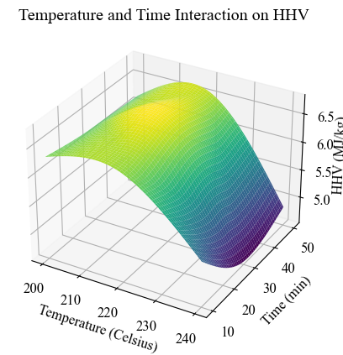

**Figure 2** Three-dimensional response surface for interaction of temperature with time on the HHV

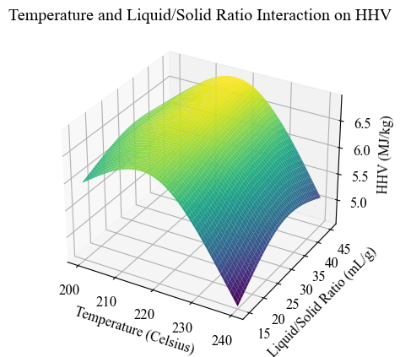

**Figure 3** Three-dimensional response surface for interaction of temperature with liquid-to-solid ratio on the HHV

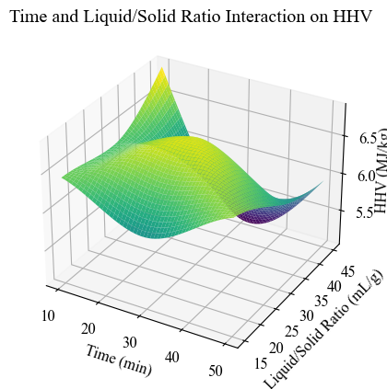

**Figure 4** Three-dimensional response surface for interaction of time with liquid-to-solid ratio on the HHV

It can be seen from the response surface of hydrothermal temperature, holding time and liquid-solid ratio to yield (**Figure 5**, **6** and **7**) that the overall trend is upward, indicating that during the reaction process, the reaction parameters involved are within infinite range. Within this value range, the yield is inversely proportional to the hydrothermal temperature, holding time and liquid-to-solid ratio. That is to say, the higher the temperature, the longer the holding time or the larger the liquid-to-solid ratio, the lower the hydrothermal carbon yield will be.

During the hydrothermal reaction of sludge, as the temperature increases, the degree of decomposition of sludge in the hydrothermal reaction intensifies. Although hydrothermal carbon with higher calorific value is formed, the yield is relatively reduced. Ekaterina [6] believes that increasing the temperature from 200°C to 260°C will reduce the average hydrothermal carbon yield by 15%, resulting in a slight loss of solid product quality, which may be due to the greater effect of the hydrolysis reaction. The longer the holding time, substances such as protein and lignocellulose gradually decompose and enter the liquid phase or oil phase during the process [7]. When the decomposition rate and polymerization rate are relatively stable, the effect of time on the yield will also be reduced.

The impact of liquid-to-solid ratio on productivity is mainly based on sludge concentration. Therefore, on the premise of ensuring the calorific value [8], the hydrothermal carbonization product hydrothermal carbon should be prepared at a relatively low temperature, a short holding time and a low liquid-to-solid ratio.

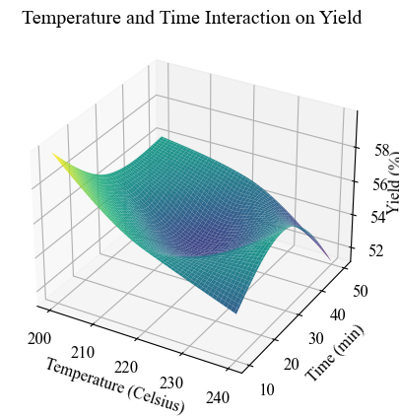

**Figure 5** Three-dimensional response surface for interaction of temperature with time on the yield

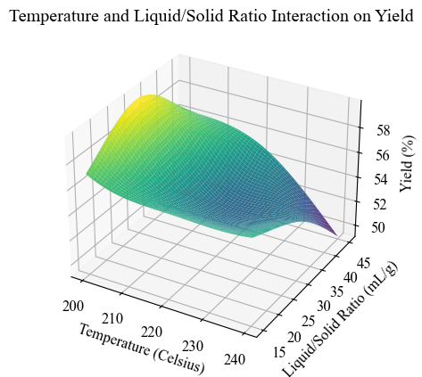

**Figure 6** Three-dimensional response surface for interaction of temperature with liquid-to-solid ratio on the yield

**Figure 7** Three-dimensional response surface for interaction of time with liquid-to-solid ratio on the yield

**Recommendations**

After hydrothermal carbonization treatment, the organic matter in the sludge changed significantly. By comparing the composition changes of sludge and hydrothermal carbon before and after hydrothermal carbonization, it can be found that after hydrothermal treatment, the carbon content and fixed carbon content in hydrothermal carbon increased significantly, and the calorific value also increased accordingly. This lays the foundation for the harmless and efficient treatment of sludge and is of great significance.

The response surface analysis results show that temperature, reaction time and liquid-solid ratio are the key factors affecting the hydrothermal carbonization reaction. Within a certain range, appropriately increasing the temperature (215~230°C) and prolonging the reaction time (25~35min) will help increase the calorific value of hydrothermal carbon, but too high a temperature (>260°C) or too long a time will aggravate the problem. Organic matter decomposes and reduces yield. Control of the liquid-to-solid ratio is also critical. A moderate liquid-to-solid ratio (20%~30%) can ensure better heat mass transfer and obtain higher calorific value, but too high a liquid-to-solid ratio will limit the reaction.

Based on the single-factor and multi-factor optimization results, under the optimal conditions of temperature 223°C, reaction time 31 min, and liquid-to-solid ratio 27%, the hydrothermal carbon obtained not only has the highest calorific value (9.63 MJ/kg), but also has the highest yield. The rate is also relatively ideal (58.9%). This optimized hydrothermal carbon not only has higher carbon content and fixed carbon content, but also has a relatively higher calorific value. Compared with raw sludge, it may provide better heating value during the coal-mixed combustion process.

Therefore, by reasonably optimizing the hydrothermal reaction conditions, the quality and yield of the obtained hydrothermal carbon can be maximized, and the reduction and resource utilization of sludge can be achieved, which has good environmental and economic potential. This hydrothermal carbonization technology can not only properly solve the problem of sludge treatment, but also make full use of the thermal energy resources in the sludge. It can be said to kill two birds with one stone. It is an environmentally friendly, economically feasible and comprehensive treatment method.

**Table 3** Physicochemical properties of feedstocks and hydrochars

|  |  |  |  |  |  |  |  |  |  |  |  |  |
| --- | --- | --- | --- | --- | --- | --- | --- | --- | --- | --- | --- | --- |
| Sample | Proximate analysis (wt.%, db) | | | | Ultimate analysis  (wt.%, db) | | | | | Fuel ratio | Yield  (%) | HHV  (MJ/kg) |
| VM | FC | Ash | C | | H | N | S | O | FC/VM |
| SS | 43.2 | 5.1 | 51.7 | 18.8 | | 5.3 | 6.2 | 1.9 | 19.2 | 0.12 | n.a. | 7.23 |
| SHC | 21.9 | 8.3 | 69.8 | 23.3 | | 2.3 | 1.1 | 0.2 | 7.6 | 0.38 | 58.9 | 9.63 |

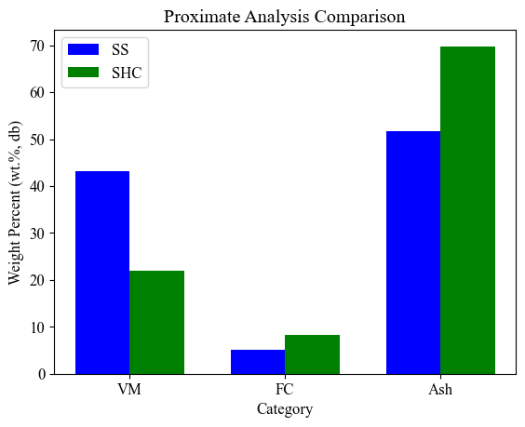

**Figure 8** Proximate Analysis Comparison between SS and SHC

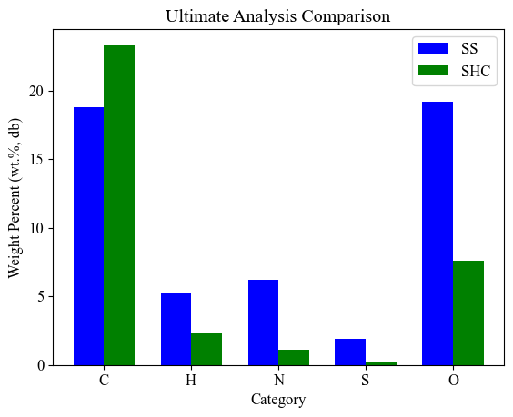

**Figure 9** Ultimate Analysis Comparison between SS and SHC

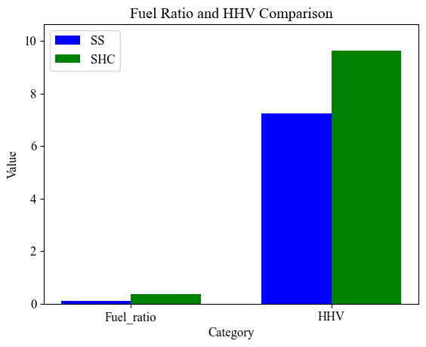

**Figure 10** Fuel Ratio and HHV Comparison between SS and SHC

**Conclusions**

Through response surface optimization, the best process conditions obtained were temperature 223°C, reaction time 31 min, liquid-to-solid ratio 27%, and the corresponding best results were: calorific value 9.63 MJ/kg, yield 58.9%. Based on the demand for sludge resource utilization, hydrothermal carbonization technology is used for corresponding treatment. Since there are many factors that affect hydrothermal carbonization, this paper uses response surface methodology to quantitatively analyze the three main factors of temperature, reaction time and liquid-to-solid ratio. Taking the calorific value and yield rate of hydrothermal carbon as indicators, we carry out corresponding experiments to optimize and innovate the hydrothermal carbonization process conditions, which is beneficial to the preparation of better-quality hydrothermal carbon products in engineering, and also determines the reaction conditions for subsequent experiments.

**Appendix**

**1.** **Implement Figure1 through python**

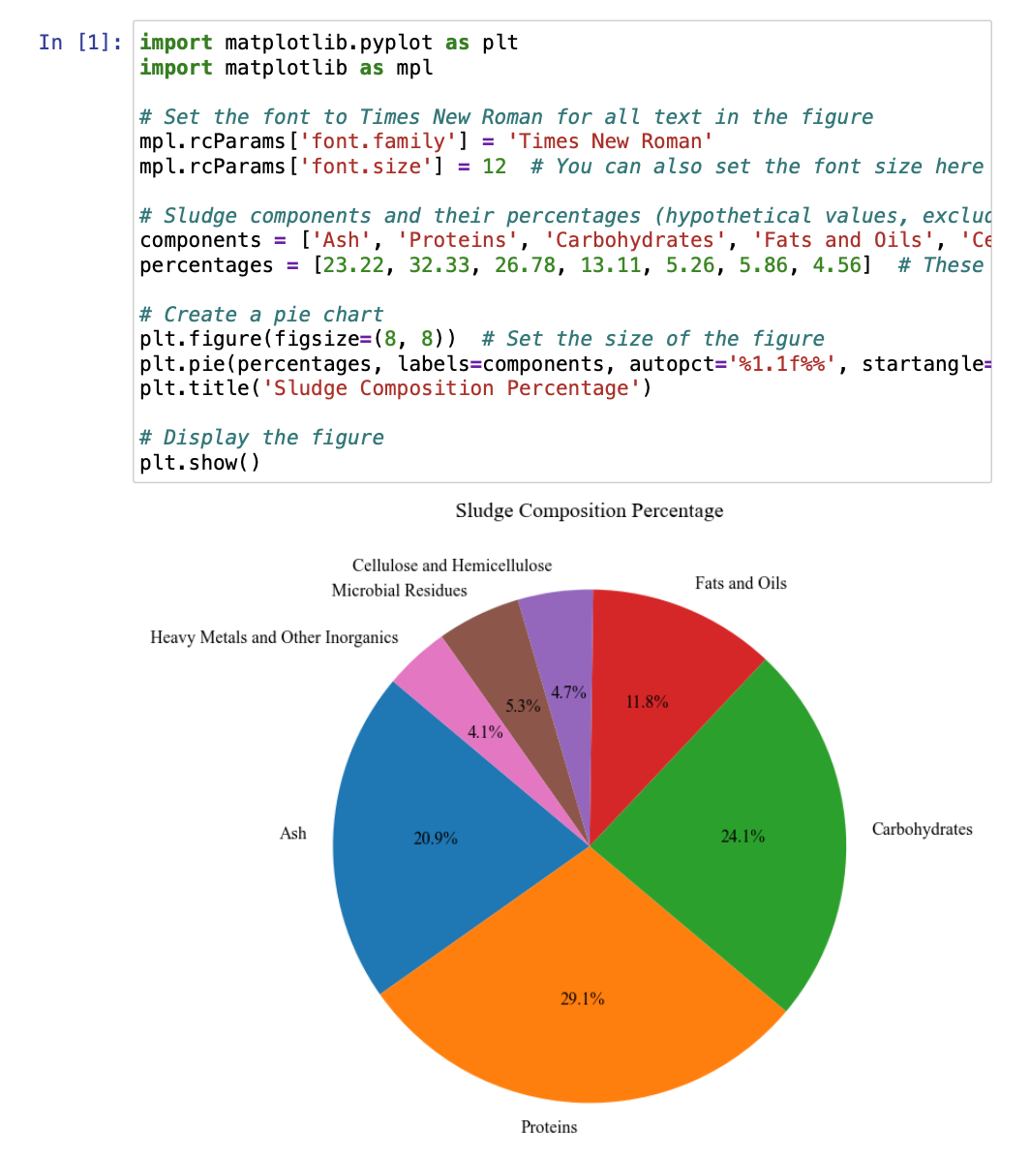

**2.** **Implement Figure 2, Figure 3 and Figure 4 through python**

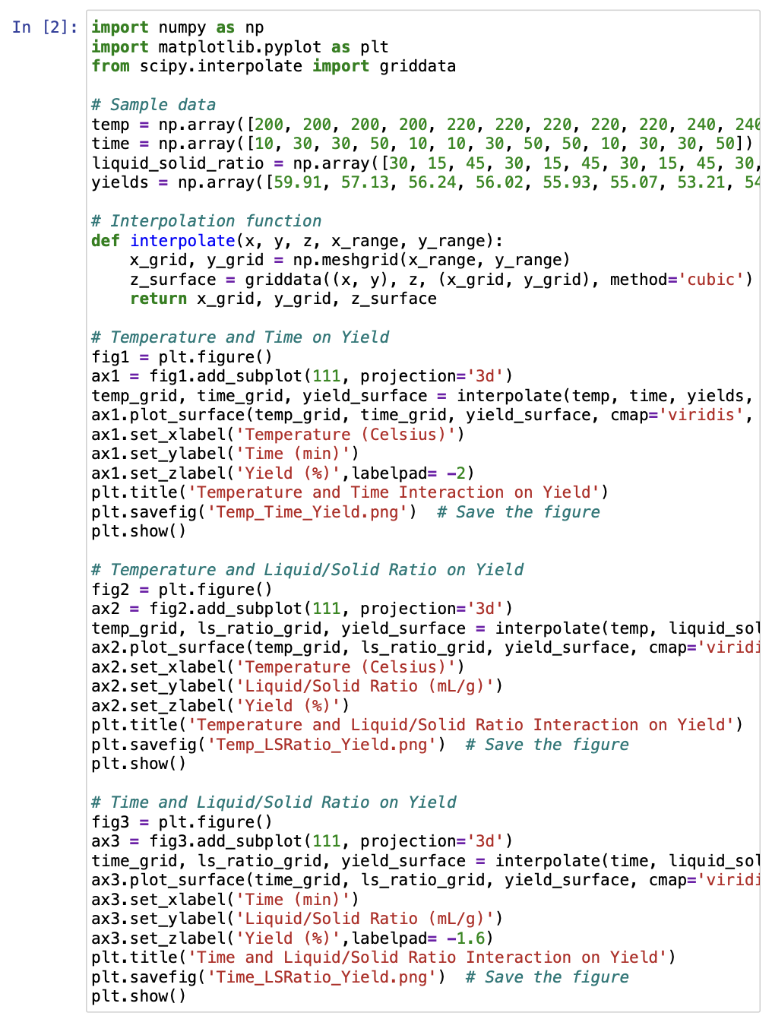

**3.** **Implement Figure 5, Figure 6 and Figure 7 through python**

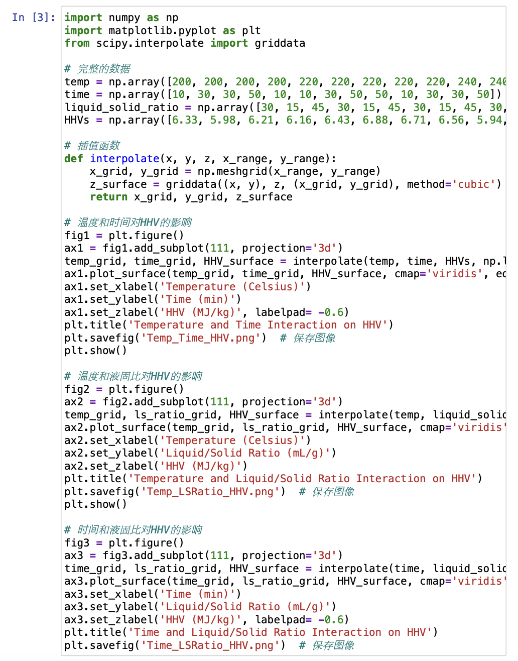

**4.** **Implement Figure 8, Figure 9 and Figure 10 through python**

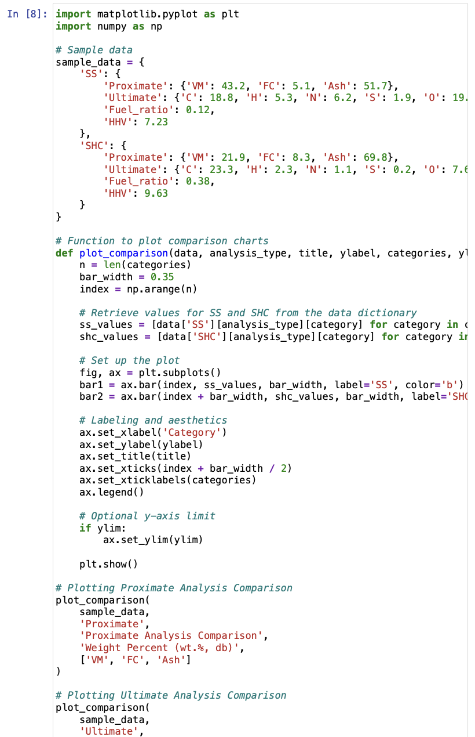

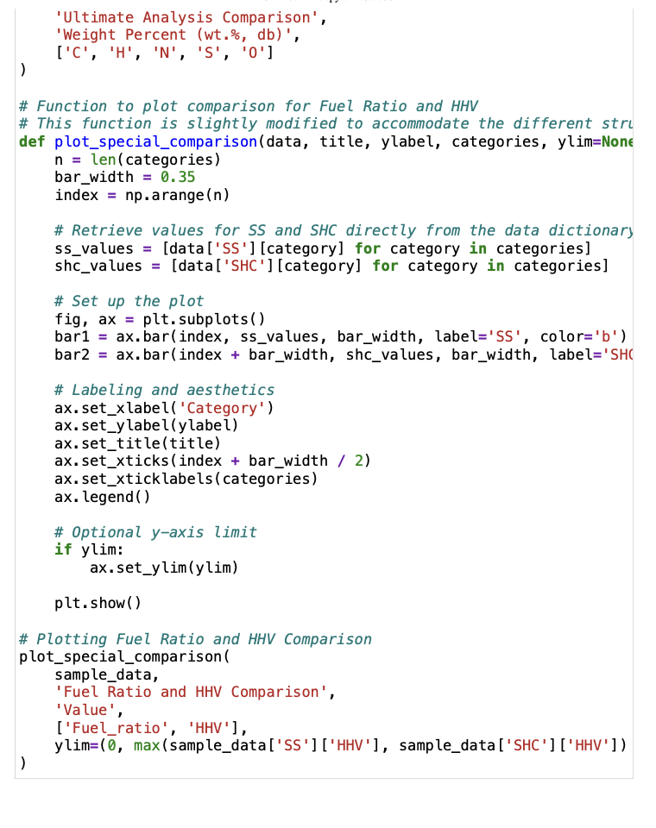

**References**

[1] Zhai Y, Peng C, Xu B, et al. Hydrothermal carbonisation of sewage sludge for char production with different waste biomass: Effects of reaction temperature and energy recycling. Energy, 2017, 127: 167~174

[2] Lin Y, Ma X, Peng X, et al. Hydrothermal carbonization of typical components of municipal solid waste for deriving hydrochars and their combustion behavior. Bioresource Technology, 2017, 243: 539~547

[3] Mu'Min G F, Prawisudha P, Zaini I N, et al. Municipal solid waste processing and separation employing wet torrefaction for alternative fuel production and aluminum reclamation. Waste Management, 2017, 67: 106~120

[4] Reza M T, Rottler E, Herklotz L, et al. Hydrothermal carbonization (HTC) of wheat straw: Influence of feedwater pH prepared by acetic acid and potassium hydroxide. Bioresource Technology, 2015, 182: 336~344

[5] Parshetti G K, Liu Z, Jain A, et al. Hydrothermal carbonization of sewage sludge for energy production with coal. Fuel, 2013, 111: 201~210

[6] Román S, Nabais J M V, Laginhas C, et al. Hydrothermal carbonization as an effective way of densifying the energy content of biomass. Fuel Processing Technology, 2012, 103: 78~83

[7] He C, Giannis A, Wang J. Conversion of sewage sludge to clean solid fuel using hydrothermal carbonization: Hydrochar fuel characteristics and combustion behavior. Applied Energy, 2013, 111: 257~266

[8] Zhao P, Shen Y, Ge S, et al. Clean solid biofuel production from high moisture content waste biomass employing hydrothermal treatment. Applied Energy, 2014, 131: 345~367

[9] Escala M, Zumbühl T, Koller C, et al. Hydrothermal Carbonization as an Energy-Efficient Alternative to Established Drying Technologies for Sewage Sludge: A Feasibility Study on a Laboratory Scale. Energy & Fuels, 2012, 27(1): 454~460

[10] Liu Z, Balasubramanian R. Hydrothermal Carbonization of Waste Biomass for Energy Generation. Procedia Environmental Sciences, 2012, 16: 159~166